# Website

*header*

| 1. A to Z Hostel Management on Mobile  2. Manage your hostel from your phone. Say Goodbye to Books  *CTA Button* - Register NOW for FREE |
| --- |

| What is Kamer?  Kamer is a mobile app for Hostel or Guest House Owners to do complete hostel management without keeping books |
| --- |

| Who can use Kamer?  Hostel owners  Hostel managers  Own 1 or more hostels  Managing 1 or more hostel buildings  Guest houses owners and managers |
| --- |

| Benefits |
| --- |

*Image reference:*

*1 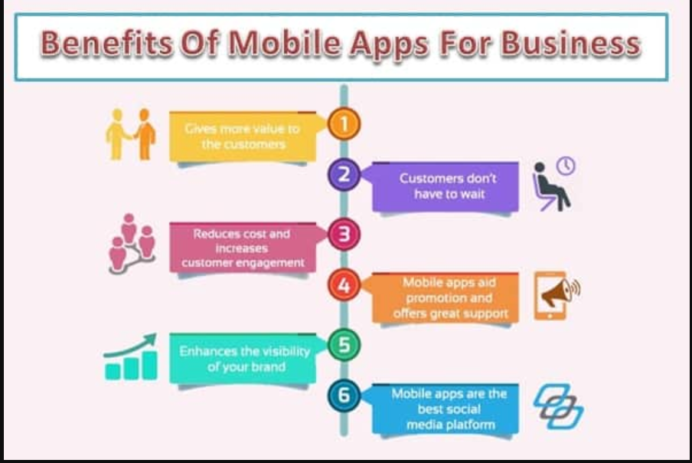*

*2*

**

* Replace so many books with 1 simple mobile app
* Track bed availability and occupancy
* Track all payments
* No losing data, organized storage of guest data
* Easily store and access Guest data
* No mismatch of data

| Manage your hostel buildings and guest houses tension-free  Register NOW for FREE |
| --- |